Group procedures manual

Credit and Debt Management Procedures
Mandatory for European & NA Regions

Version 1.0 (Final)
Date: 23rd July 2010
Author: Charlotte Maben & Andrew Monkhouse
Owner: Brian Tenner

TABLE OF CONTENTS

Introduction 1
1. New Account Opening Process 1
1.1 Opening and Activation 1
1.2 SAP Risk Categories 2
2. New Account Opening Process 3
2.1 Held Orders 3
2.2 Reviewing Accounts 4
2.3 Credit & Delivery Block 5
3. Approval to Change Credit Limit/Payment Terms 6
4. Collections, Escalation Process & Debt Review 7
4.1 Collections 7
4.2 Escalation Process 8
4.3 Debt Review 9
5. Proactive Management of Credit Limits 10
6. Credit Insurance Policy 11
6.1 Application for New Accounts 11
6.2 Notification of Non-Payment 12
6.3 Amendment/Withdrawal of Coface Limit 13
6.4 Credit Limit Changes following Account Review 13
6.5 Coface Country Zones 14
6.5 Coface Policy Compliance 14
7. Accounts in Receivership/Administration 16
8. Write Off Process 17
9. Monthly Statement Run 17
10. Proforma Orders 19
11. Monies on Account 20
Appendix – Process Flowcharts 21
a. New Account Opening Process 21
b. Orders on Hold or Stopped 22
c. Proactive Collections 23
d. Processing Insurer Limit Changes 24
e. Debt Review and Escalation Process 25
f. Debt Write Off 26
g. Statement Despatch 27

Introduction
This document contains the mandatory Credit and Debt Management procedures which apply to all SAP supported Scapa sites where credit control and debt management activities operate.
It includes Coface insurance procedures, which must be applied against all insured accounts.
The procedures and controls are endorsed by the Group Finance Director and should be read in conjunction with the Minimum Control Standards document, available on the Intranet.
The document is comprised a written procedures, screen shots and a series of support flowcharts to provide an overview of the key processes. The manual assumes a good basic prior understanding of Credit and Debt management concepts.

1. New Account Opening Process

1.1 Opening and Activation
- Receive a completed Customer Account Opening form, authorised by Sales Manager (including sub accounts to a master account e.g. Delivery Accounts).
- Obtain D & B Credit Risk report & retain hard copy with account set-up documents.
- Apply for Coface cover if necessary in line with the Credit Insurance Policy(please note maximum terms that can be offered under Coface policy are 150 days from date of invoice), if adequate cover not available negotiate with RKH for increased cover, if still unable to get level of cover required please raise this with Scapa Group Financial Controller who may be able to intervene for increased cover.
- Agree payment terms (for standard terms by country see intranet – Documents tab) risk category (with help selecting risk category see table below) & credit limit & obtain authorisation in line with authority matrix.
- Amend Customer Account Opening Form if necessary & return to Customer Care along with Application for New Credit Account reflecting the terms agreed for completion by customer.
- On receipt of completed & signed Application for Credit Account with company letter headed paper & CMDT approval account can be activated.
- Set agreed credit limit in SAP FD32 - Credit Limit, enter account number & press F7 to check all boxes, enter credit limit data in second screen, if sharing a credit limit across Europe the overall limit and the individual limit will differ, if not these amounts will be the same, enter limit details & relevant currency.
- In the third screen enter individual limit required, again this will be the same as the overall limit unless the overall limit is shared across Europe.
- Enter relevant risk category from Customer Account Opening form.
- Enter D & B data in the External Data section & save.
- In SAP XD02 - New Accounts Customer Master enter new account number, check address & trading style.
- Select Company Code Data & Payment Transaction tab to check payment terms are correct.
- If incorrect select FD02 - Change Customer (Accounting), Company Code Data & Payment Transaction tab & amend.

- Also amend in VD02 - Change Customer (Sales), select Sales Area Data & Billing Document tab.
- In SAP XD02 - New Accounts Customer Master, select Company Code Data & Correspondence tab to enter Dunning data, Dunn.Proceedure should be set to 0007 & Dunning Clerk needs to be set to the correct business unit.
- In Correspondence select Extras, Blocking Data & remove the blocking code.
- Where Coface cover exists select Insurance tab & enter detail, under institution number enter the Coface score & under policy number add the Coface quick reference.
- Account is now active, notify Commercial and file account set-up documents.

North America Deviations
- Customer Account Opening form is signed off by the CCA (Customer Care Agent).
- First valid PO must be received in conjunction with customer filled out and signed credit application before CCA will even enter the customer into SAP.
- CCA will fill out the New Account Approval form and sign-off once they have entered the account into SAP
- New Account Approval form along with signed credit application remains on file in Accounting department

1.2 SAP Risk Categories
The tables below provide guidance in relation to the use of European SAP Risk Categories.

Risk Category | Credit Group | Checks Performed | Block | Warning
001 Open Item Standard Risk | 01 Sales Order | Dynamic - Horizon 30 days | Y |  | For accounts where there are limited concerns regarding risk and for all accounts that have a Coface discretionary limit.
001 Open Item Standard Risk | 01 Sales Order | Document Value £50,000 |  | Y
001 Open Item Standard Risk | 01 Sales Order | Oldest Open Item 15 days | Y
003 Open Terms High Risk | 01 Sales Order | Dynamic - Horizon 61 days | Y |  | For accounts where there is considered to be a higher level of risk
003 Open Terms High Risk | 01 Sales Order | Oldest Open Item 0 days | Y
003 Open Terms High Risk | 02 Delivery | Dynamic - Horizon 61 days | Y
003 Open Terms High Risk | 02 Delivery | Oldest Open Item 0 days | Y
007 Coface | 01 Sales Order | Dynamic - Horizon 30 days | Y |  | For accounts that have an agreed Coface credit limit or @ rating
007 Coface | 01 Sales Order | Document Value £50,000 |  | Y
007 Coface | 01 Sales Order | Oldest Open Item 30 days | Y
007 Coface | 02 Delivery | Static | Y
007 Coface | 02 Delivery | Document Value £50,000 |  | y
007 Coface | 02 Delivery | Oldest Open Item 30 days | Y

Owing to local differences, the following provides guidance in relation to the use of NA SAP Risk Categories.

Risk Category | Credit Group | Checks Performed | Block | Warning
100 Open Item Standard Risk | 01 Sales Order | Dynamic - Horizon 30 days | Y |  | For accounts where there are limited concerns regarding risk.
100 Open Item Standard Risk | 01 Sales Order | Document Value $250,000 | Y
100 Open Item Standard Risk | 01 Sales Order | Oldest Open Item 20 days | Y
002 High Risk | 01 Sales Order | All orders |  |  | Payment must be received prior to release

2. New Account Opening Process

2.1 Held Orders
- Orders, deliveries & quotations will enter the held file (VKM1 - Credit Hold) daily.
(ensure the relevant credit control area is selected EU10 = UK & EU20 = rest of Europe)
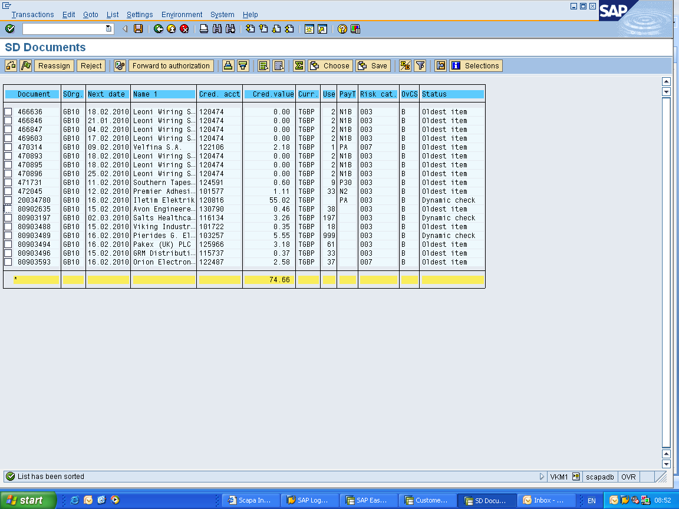

Orders

Quote
Delivery Notes

- Quotes can be released immediately as there is no physical stock being despatched therefore nothing of any monetary value is being sent. (Quotes are not used in NA).
- Some orders will have a zero value these are free of charge sample orders & can be released immediately.
- For orders & delivery notes individual customer accounts need to be investigated to establish if goods can be released for production or shipment.
- Use FBL5N – Customer Line Items to review account.

2.2 Reviewing Accounts
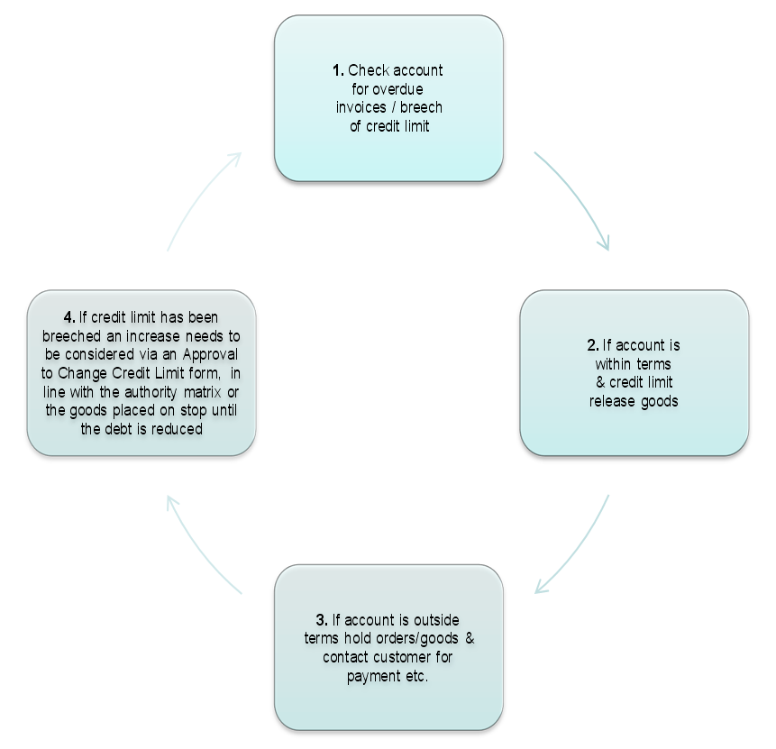
- Any account put on block must be notified to relevant departments.
- A hard copy of the stop list is produced at the beginning of each day listing all accounts on stop by exporting VKM1 into Excel and circulated to relevant Commercial, Customer Care, Production and Shipping staff. Any accounts placed on full credit block are also added to the list.
- Any actions taken are recorded in the text field on the relevant account.

2.3 Credit & Delivery Block
- A full credit & delivery block is used to stop any new order being input into SAP and to hold any stock in production from being despatched & should be added to an account when:
- Debt is > 30 days from due date (excluding automotive for IT10 & FR10) assuming there are no ongoing claims on the account.
- Adverse information has been received.
- Customer deviates substantially from usual payment history.

  - A credit & delivery block is placed on an account in either:

VD05 - Block customer (sales)
XD02 – New Accounts Master
- Blocks must be added in SAP as shown below:
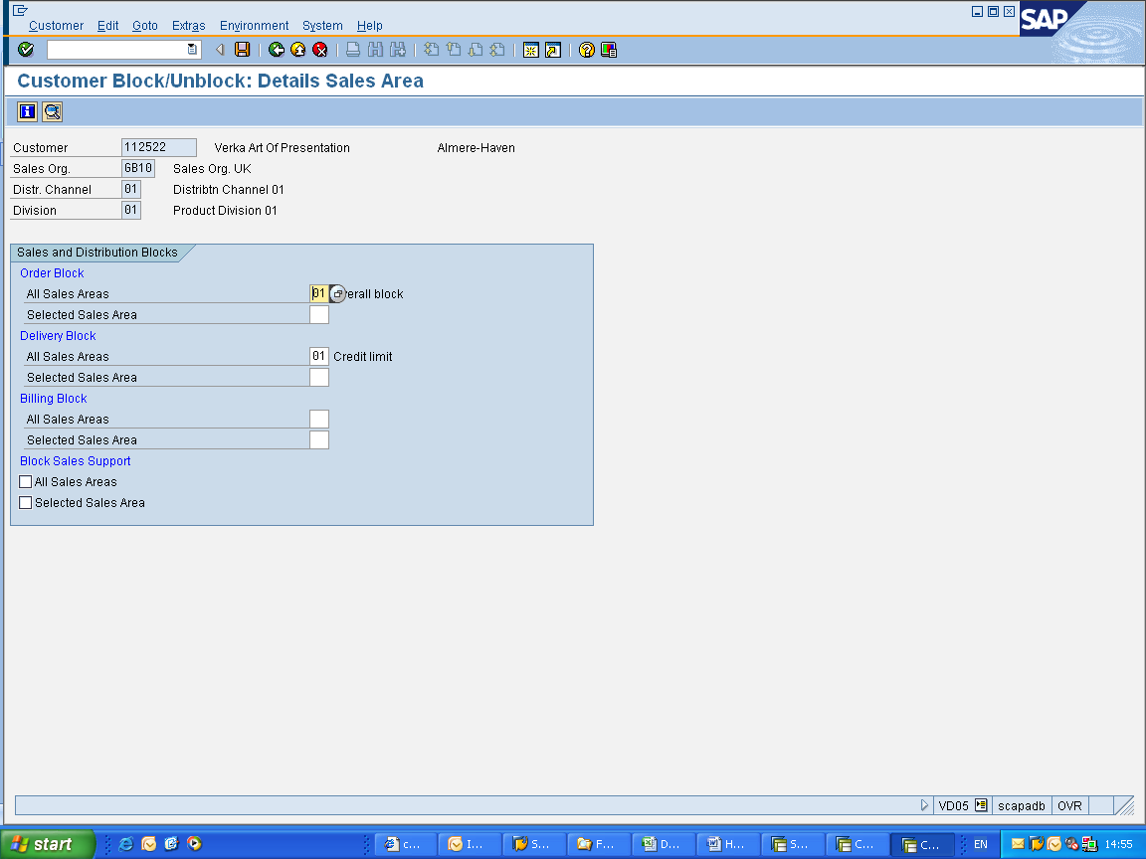
NB Billing blocks must not be added
- When payment issues are resolved blocks are removed by deleting the 01 code shown above & saving changes.

3. Approval to Change Credit Limit/Payment Terms
Accounts requiring a change to either the credit limit or payment terms should be identified as a result of daily credit control duties such as appearing on the stop list, through proactive management of credit limits or as a request from the customer or Commercial. To make changes in SAP:
- Identify account where a change is required to credit limit/payment terms.
- Complete or receive a completed Approval to Change Credit Limt / Terms form.
- Obtain any relevant supporting documentation i.e. D&B reports, Coface Limit Notification, reduced spending etc.
- Ensure the form is authorised in line with authority matrix.
- Amend details in SAP:
- FD02 - Change Customer (Accounting) - Payment Term Changes
- VD02 - Change Customer (Sales) - Payment Term Changes
- FD32 - Credit Limit – Credit Limit Changes
- When changing payment terms both the sales and accounting areas must be changed in SAP.
- Remember to amend Coface data in SAP if necessary.

- File hard copies of all paperwork with customers original set-up paperwork.

NB Where a shared credit limit exists across Scapa entities consider carefully the changes being proposed.

4. Collections, Escalation Process & Debt Review

4.1 Collections
- The SAP text fields next to each line item (invoice) on the debtors aging should be used to insert collection comments. In addition the detailed text section in transaction S_ALR_87012218 (Credit Master Sheet) should be sued to input more information about direct work with the customer and the commercial team.
AS an alternative to using the notes in SAP:
- Produce debt report in SAP weekly:
  - SQ01 - SAP Query: Maintain queries
  - DR_DYNC_AGEING
- Manipulate report in excel to remove subtotals & interco debt. Add an extra column showing overdue debts & a final column for comments.
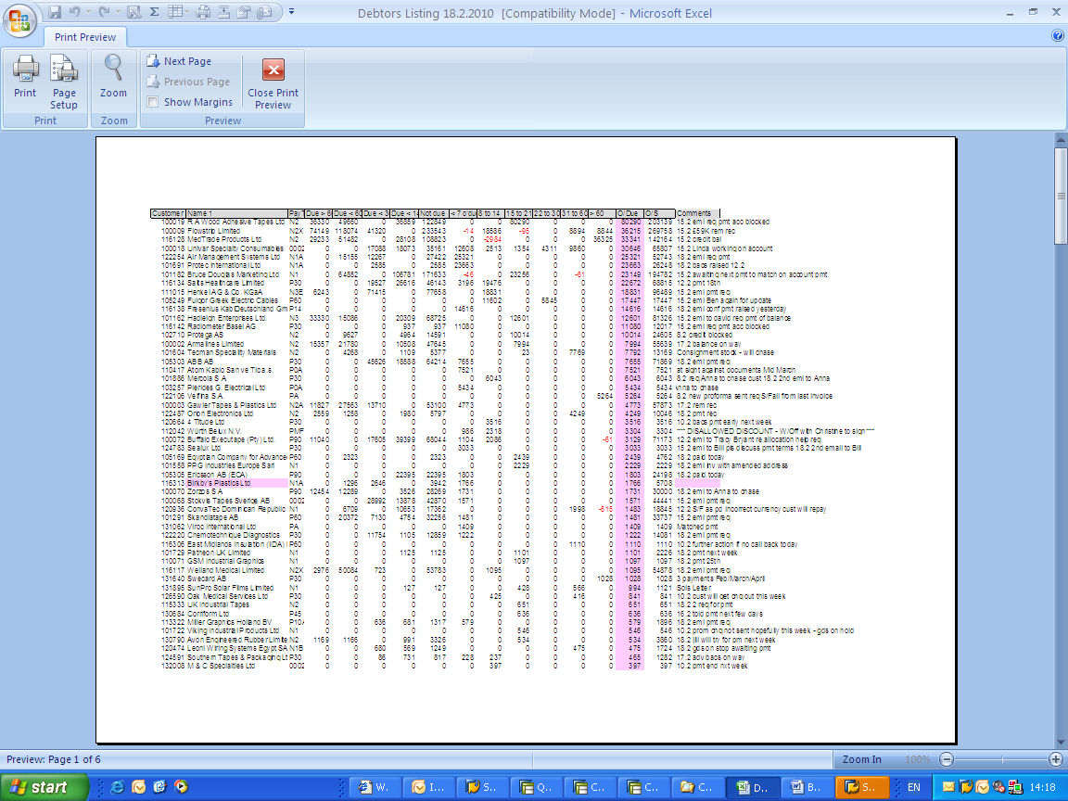
- In excel perform a VLOOKUP to pull through any previous comments & data sort spreadsheet by overdue debt, highest value & then by outstanding debt, highest value.
- Review & replace previous comments & chase customer where necessary i.e. failed payment promise.
- Highlight accounts where there is an overdue debt & forward to Customer Care Manager weekly, with a note explaining that the highlighted accounts could be placed on stop were an order to be received.
- Contact customers for payment information regarding new debt & add comments to the spreadsheet & the text field in FBL5N - Customer Line Items.
- Where necessary obtain assistance from Customer Care / Commercial i.e. customer delaying payments or account query.
- Once all accounts with an overdue debt have been contacted look for accounts where invoices are due within the next week and contact proactively for payments. Contact in the usual manner, confirm they have all invoices, that there are no queries preventing payment & request a payment date for the relevant amount. (Local judgement should be used if chasing debts before due date is liekly to upset customers).
N.B Accounts that need to be contacted for payment can also be identified daily via the Held File
- North America utilizes the SAP text fields next to each line item (invoice) on the debtors aging to insert collection comments. We also utilize the detailed internal text section in transaction S_ALR_87012218 (Credit Master Sheet) to input more information about our direct work with the customer and the commercial team. No need to put comments into Excel.
- Orders are blocked upon entering if there is an issue with the customer account regarding non-payment or over limit issues. North America does not send out a weekly report to Customer Care of the potential accounts that could be stopped. Seen as inefficient when you have a system that does this work for you.

4.2 Escalation Process
- Identify accounts for escalation:
  - Failure to advise of payment date.
  - Debt > 15 days overdue with no explaination or promise to pay.
  - Failed payment promise with no explaination or promise to pay.
  - Adverse information i.e Coface notification or Commercial information.
- Communicate issues to Customer Care / Commercial requesting assistance.
- Notify as potential bad debt in line with authority matrix if unable to resolve .
- Consider & agree actions:
  - Credit Block.
  - Obtain current D&B.
  - Re-check trade references provided when account opened.
  - Change in Payment Terms / Credit Limit.
  - Solicitors Action.
  - Pass to Coface (via RKH) for collection – any account can be passed to Coface for collection regardless of wether or not we have cover.
N.B Where notification of receivership has been received please follow the process for accounts in receivership

4.3 Debt Review
- A full debt review must be carried out on a weekly basis with the Finance Director / Financial Controller to ensure that all debts are being collected & escalated in accordance with the agreed company policy.
- A hard copy of the current debt report is reviewed in a 1-2-1 meeting discussing specific accounts and agreeing actions.
- The debt report is signed off by the Finance Director / Financial Controller & retained for audit purposes.
- Any bed debt provision requirement can be detailed by FD / FC.

5. Proactive Management of Credit Limits
- Every six months a review of all Scapa credit limits & Coface credit limits should be carried out to ensure that correct limits are in place to reflect current purchasing levels.
- Run SAP report F.31 - Credit Management – Overview, this gives the Scapa credit limit & compares this to the credit exposure giving an overall % of credit limit used.
- Select only those accounts with a value in the credit exposure field and data sort spreadsheet by column Credit Limit used, largest to smallest.
- Accounts with >80% of credit limit used should be reviewed for an increase in line with Approval to Change Credit Limit / Payment Terms Process (Pg 6).
- Where credit limit increase is not supported communicate to Commercial & Customer Care & agree how to resolve issues with individual customers.
- Accounts with <20% of credit limit used should be reviewed for a decrease in line with Approval to Change Credit Limit / Payment Terms Process & Customer Care who may understand why purchasing levels have decreased i.e. seasonal trend.

NB Where a shared credit limit exists across Scapa entities consider carefully the changes being proposed.

6. Credit Insurance Policy (Europe Only)

6.1 Application for New Accounts
Credit limit < €15K – Zone 1 >> Apply discretionary limit
In order to qualify for discretionary limit we must have:
- 6 months trading history proving the customer has traded at the required level and has paid satisfactorily
- A D&B credit report (or similar) with a recommended credit limit for the required level
Credit limit < €15K – Zone 2 –
failed discretionary >> Is @ rating
Or greater then €15K – Zone 1 or 2 available
No @ rating available >> Request formal credit limit
If formal credit limit is refused or reduced >> Liaise with R K Harrison (RKH)
If RKH unable to help >> Escalate to Scapa Group Financial Controller
If Scapa Group FC unable to help >> Investigate top up limit
If cover still inadequate >> Escalate via authority matrix
Record all Coface data in SAP >> XD02 – New Account Customer
Master
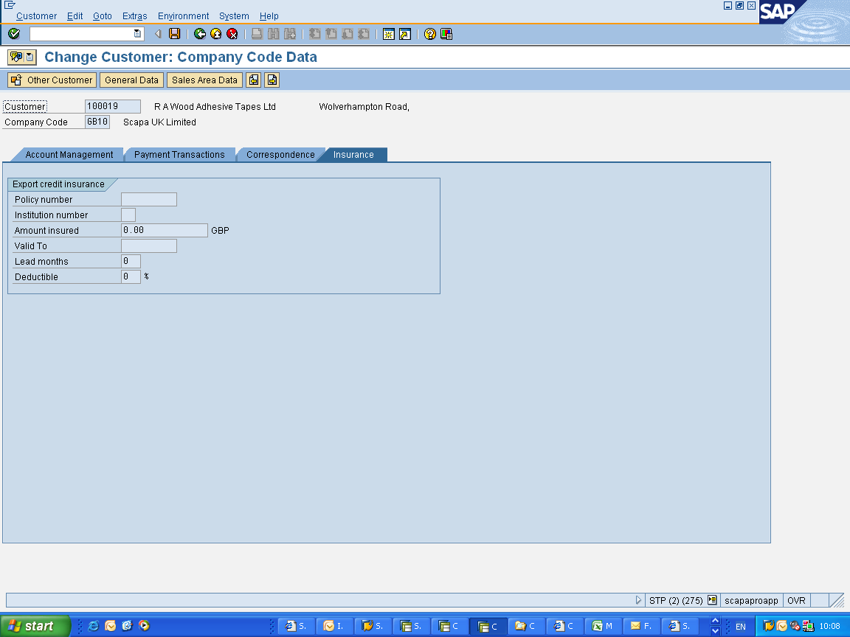

NB When applying for credit limits in Cofanet always enter sales organisation and customer number
in the customer reference field e.g. GB10 102135

6.2 Notification of Non-Payment
- 170 days after payment due date of an invoice notification of non-payment must be given to Coface via R K Harrison (RKH) – Andrew.lane@rkhfr.com (the maximum time is 180 days but this process builds in 10 days to ensure we capture all invoice in time to claim).
- Account to be placed on credit block in SAP.
- Inform Commercial & Customer Care.

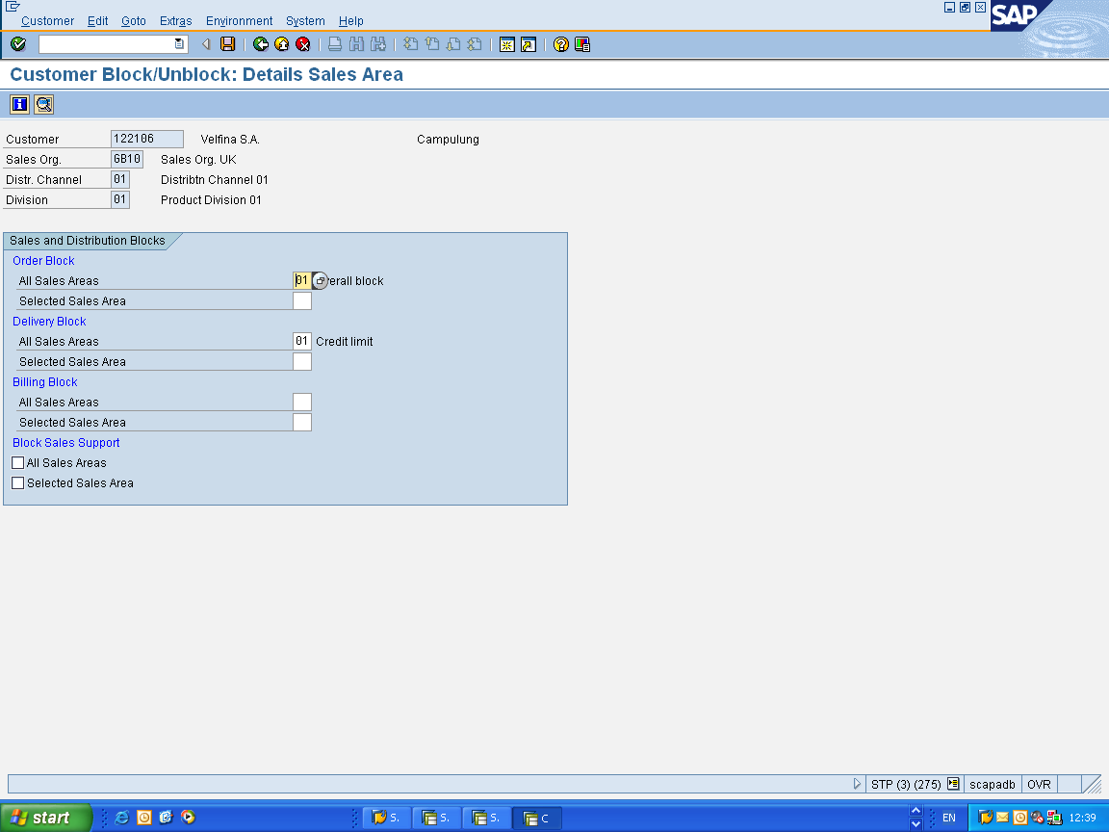

- Complete notification / collection form when received from Coface.
- If customer pays withdraw notification & review credit terms.
- If no payment complete Coface claim form on receipt, this allows Coface to commence recovery of the debt.

6.3 Amendment/Withdrawal of Coface Limit
If Coface cover is reduced / withdrawn the order book at that point is covered by insurance, to capture the order book and debtor balance @this time:
- Screen shot of FD32 showing outstanding debt + open orders at the date the Credit Limit was pulled.
- Excel spreadsheet output of FBL5N - Customer open items – this shows all invoices that are outstanding.
- Using the above will allow the “Ceiling” invoices to be identified.

Action to take:
- Amend Risk Category & insurance tab in SAP.
- Calculate timeline for amending credit limit in SAP, based on confirmed & open orders.
- Block new orders by adding an order block only in SAP (this would need to be tested to ensure confirmed and open orders in SAP would still be released), this limits the exposure.
- Inform Customer Care who can liaise with Operations & the Customer.
- Prepare a new Approval to Change Terms / Credit Limit form.

6.4 Credit Limit Changes following Account Review
- On receipt of completed Approval to Change Terms / Credit Limit form access Cofanet for relevant cover.
APP II
- @ Rating – if not available or too low
- Credit Limit – if still refused or too low discuss with RKH

If RKH unable to negotiate higher cover
- Consider top-up cover
- Escalate for credit decision
- Record in SAP

6.5 Coface Country Zones
Code | Country | Zone | Code | Country | Zone
AR | Argentinia | 2 | LT | Lithuania | 2
BE | Belgium | 1 | MY | Malaysia | 1
BR | Brazil | 2 | MX | Mexico | 2
BG | Bulgaria | 2 | MA | Morocco | 2
CA | Canada | 1 | NL | Netherlands | 1
CL | Chilie | 2 | NO | Norway | 1
CN | China | 2 | PK | Pakistan | 2
CO | Columbia | 2 | PE | Peru | 2
CY | Cyprus | 1 | PL | Poland | 2
DK | Denmark | 1 | PT | Portugal | 2
DO | Dominican Republic | 2 | RO | Romania | 2
AE | Dubia | 1 | RU | Russia | 2
EC | Ecqudor | 2 | SA | Saudi Arabia | 2
EG | Egypt | 2 | XS | Serbia | 2
FI | Finland | 1 | SK | Slovakia | 2
FR | France | 1 | ZA | South Africa | 2
DE | Germany | 1 | ES | Spain | 2
GB | Great Britain | 1 | SE | Sweden | 1
GR | Greece | 2 | CH | Switzerland | 1
HU | Hungary | 2 | SY | Syria | 2
IE | Ireland | 1 | TN | Tunisia | 2
IL | Isreal | 2 | TR | Turkey | 2
IT | Italy | 2 | UA | Ukraine | 2
LV | Latvia | 2 | US | USA | 1

6.5 Coface Policy Compliance
Please find detailed below some of the essential elements of the Coface Policy, failure to comply with any of these requirements will render any claim invalid and no payment will be made.
1. Maximum credit period of 150 days from date of invoice.
Whilst you will often agree shorter credit terms with individual buyers, this allows credit terms of up to 150 days (from date of invoice). Refer any longer terms to RKHFR.
2. Maximum invoicing period of 7 days from delivery.
Refer any longer period to RKHFR.
3. 180 day time limit for “notification” of overdue accounts.
Whatever terms are agreed with individual customers, there is an obligation to “notify” an account where there are amounts unpaid at 180 days from invoice date.
An account may need notifying earlier if:
- cheques are not paid on second presentation or Direct Debits not met,
- repayment plans are requested which would take any of the proposed payments beyond the 180 day period. These need to be considered and hopefully accepted by Coface prior to making any agreement with the buyer,
- you believe that the buyer’s financial situation is such that a loss is likely to arise, or
- you become aware that the buyer has entered into Liquidation.
If any of these circumstances in paragraph 3 above arise, the reporting is done by you completing a Coface “notification/collection” form and forwarding to andrew.lane@rkhfr.com and roger.johnson@rkhfr.com.
- Depending on the circumstances of the notified account, Coface will then take over the collection action on your behalf.
- Prior to this, you should have taken:
  - your own action to collect the debt in accordance with your cash collection procedures,
  - whatever action is necessary to prevent or minimise the loss for both Coface and yourselves.
- Coface will keep you advised about their progress in collecting the amount owed to you. They will also let you know when a “claim” form is required.
- In any event, a “claim” form should be completed within 6 months of the account being “notified” to Coface.

Please send all “notifications/collections” and “claims” documentation to RK Harrison Financial Risks Ltd and not to Coface. This will give RKH the opportunity to resolve any questions which may be raised by the Coface collectors and claims examiners and to provide any additional documentation which will be required to support any claim. This will enable RKH to represent our interests in the best possible way to obtain the maximum possible settlement in the minimum timescale.

7. Accounts in Receivership/Administration
- Receive notification of receivership / administration.
- Place order & delivery block on account - VD05 - Block customer (sales).
- Notify Customer Care & Commercial via email.
- Contact Receiver / Administrator to establish if any goods can be collected under ‘Retention of Title’.
- Complete paperwork & return to Receiver / Administrator.
- If covered by Coface notify via R K Harrison & complete all relevant paperwork to allow claim to be settled in line with Credit Insurance Policy
- Once Receiver / Administrator has completed their business & notified of any payments any remaining debt should be written off following the Write Off Process
NB On occasion an Administrator may want to continue to trade in which case they will supply the paperwork to change the account name (if there is no debt) or to set up a new account with the original name, trading in administration i.e.

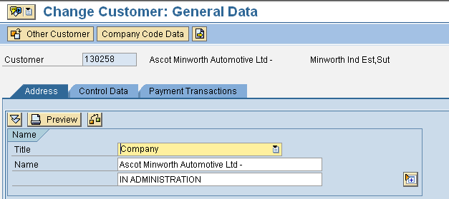

The administrator will guarantee payment providing each order supplied has been signed by an authorised member of the administration team, these signatures will be supplied by the Administrator.

8. Write Off Process

- Identify account / amount for write off
  - Failure to pay – gone away
  - Account in Receivership/Administration
  - Agreed short payment

- Complete Write Off form & obtain authorisation in line with authority matrix
APP__I

- Action write off in SAP and retain paperwork for audit purposes

9. Monthly Statement Run

(Statements do not have to be produced in North America owing to the greater number of smaller customers).

Statements are created on the first working day of each month, to create statements:

- F.27 - Print Statements
- Select correct variant

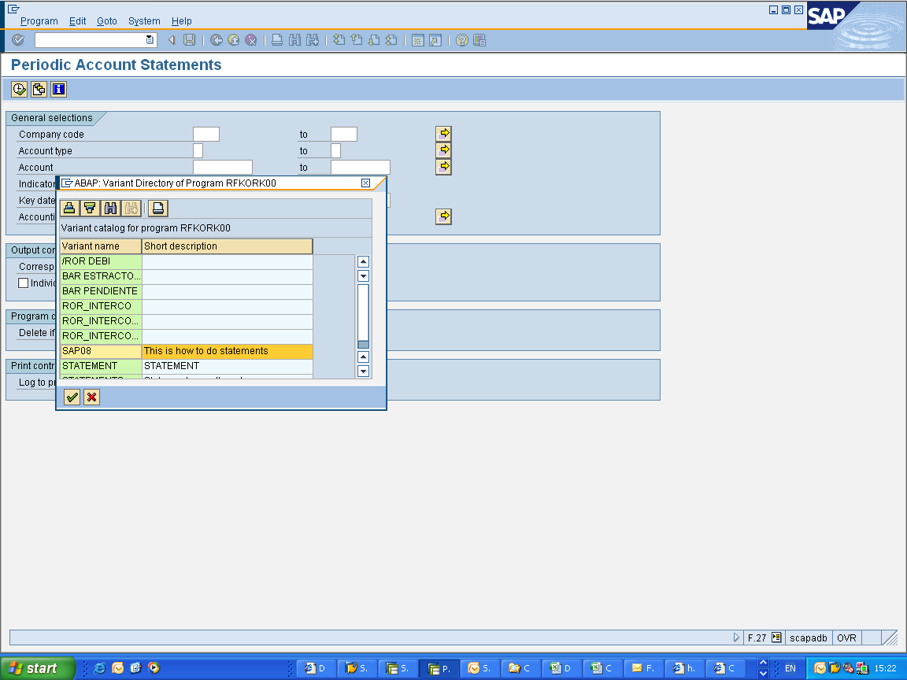
Add account number selection & correct date, which is always the last working day of the previous month.
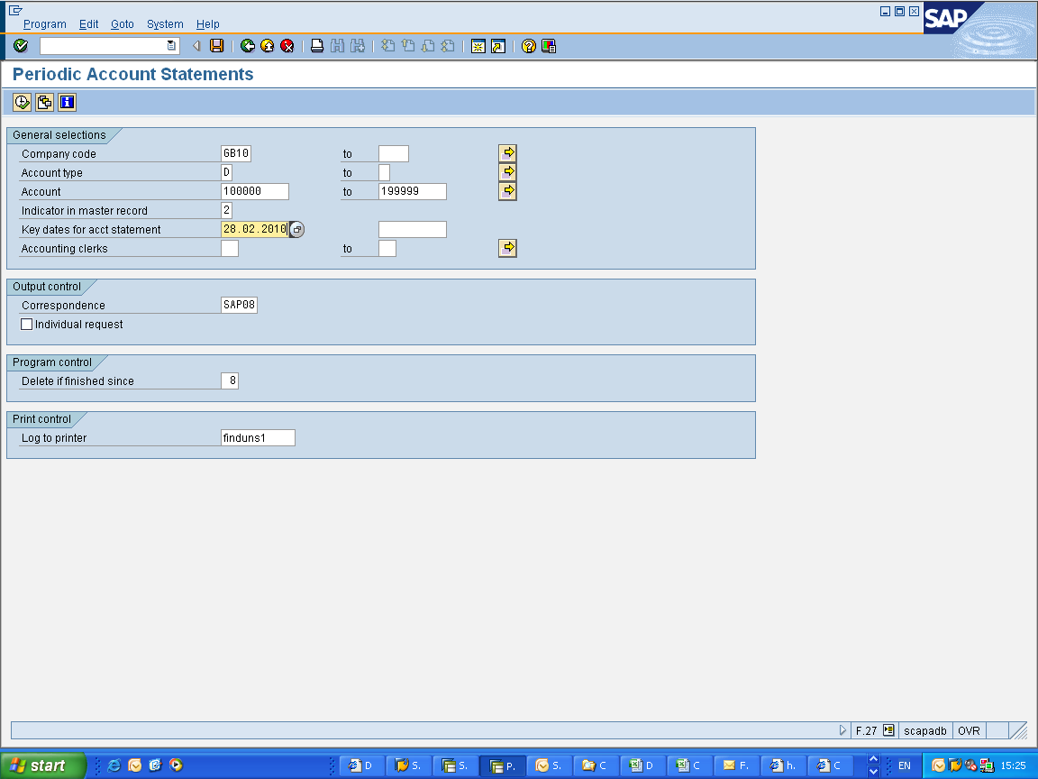
- Create prints in System, Own Spool Requests
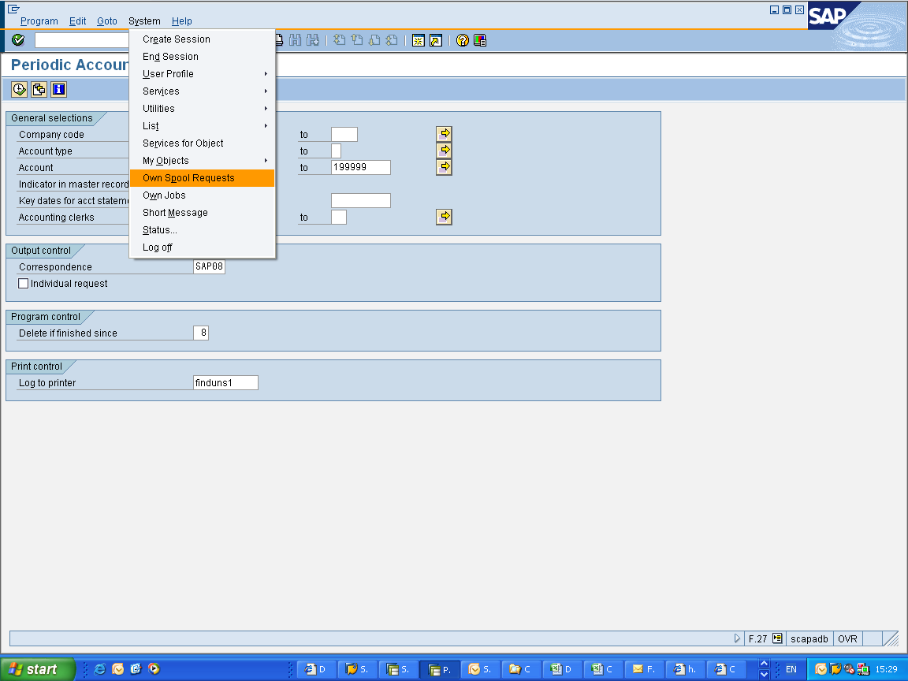
- Once printed on correct letter headed paper remove any intercompany statements & post to customers

10. Proforma Orders
Accounts where PA Terms (Payment in Advance) are in place are required to pay us for goods prior to Scapa commencing production. The order will be input into SAP by Customer Care which then creates a proforma invoice. A copy of this should then be sent to the customer for payment to be raised and a copy to Credit Control.

Once in SAP the order will enter the held file where it will remain until the funds have been received, upon receipt the goods are released and Customer Care informed.

The account should be reviewed regularly for allocation of the payment against the invoice once it is created in SAP:

- F-32 - Conrta Credit/Debits – double click on the items being matched and save to update the account

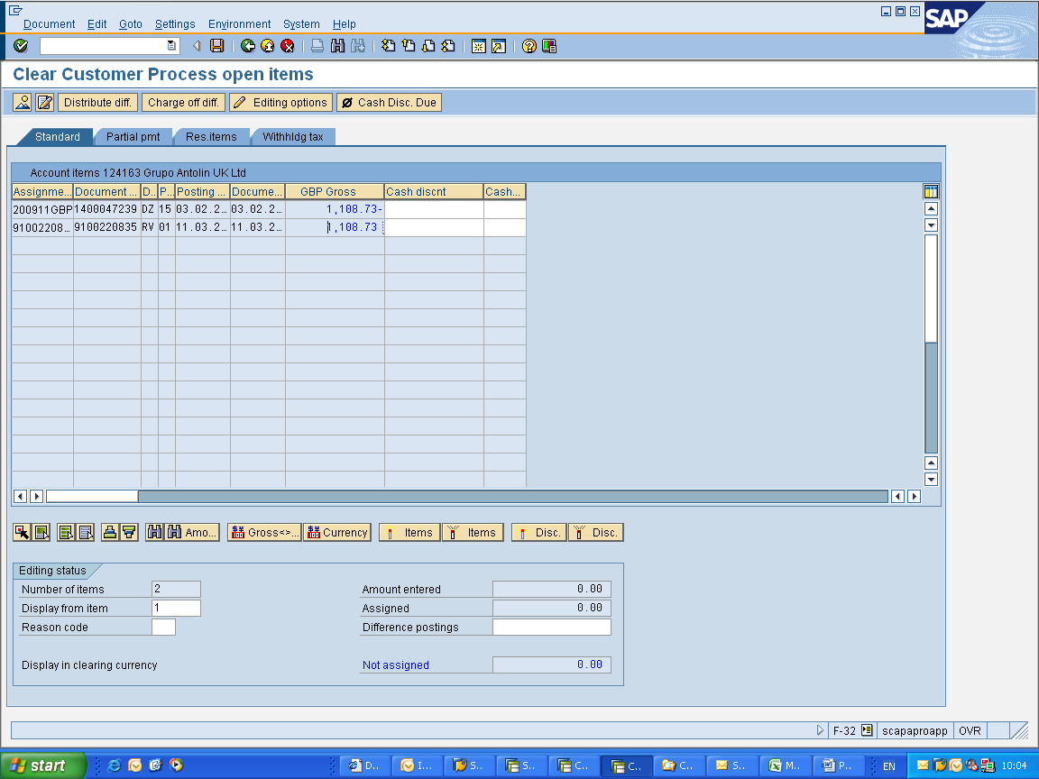

- The original invoice will be sent to the customer by Customer Care

11. Monies on Account
There are instances where Cash Allocation has to place funds received on account without actually allocating the funds:
- Proforma payment so no invoice in SAP to allocate funds against
- No remittance so unable to identify which items to allocate funds against
- Payment received for too much / not enough so unable to allocate
- Paid in the incorrect currency so unable to allocate
- Discount disallowed as taken outside payment terms

Any funds being placed on account by Cash Allocation must be notified to Credit Control immediately so that the appropriate action can be taken to resolve the issue and clear the account:
- Releasing proforma order and notifying Customer Care
- Requesting remittance advice from customer
- Customer contacted with relevant query

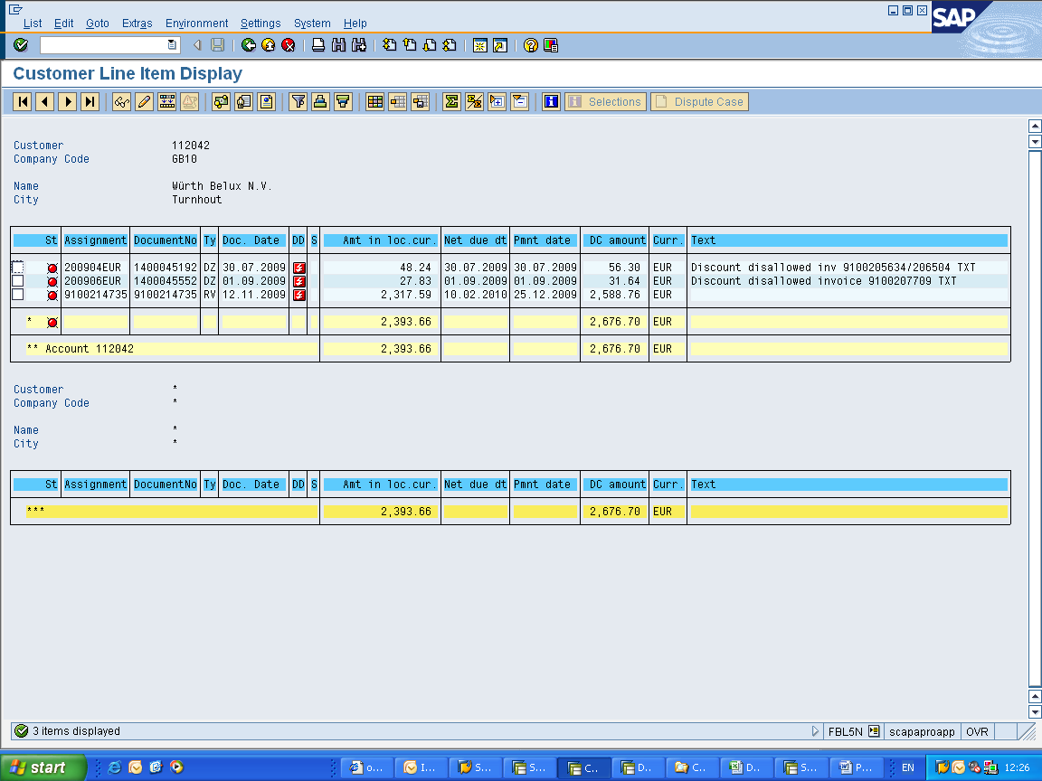

- Monies on account should be easily recognised by the document number as shown above
- Once issues resolved continue to check account until funds have been repaid / allocated, if necessary allocate the funds as agreed with the customer

Appendix – Process Flowcharts

a. New Account Opening Process
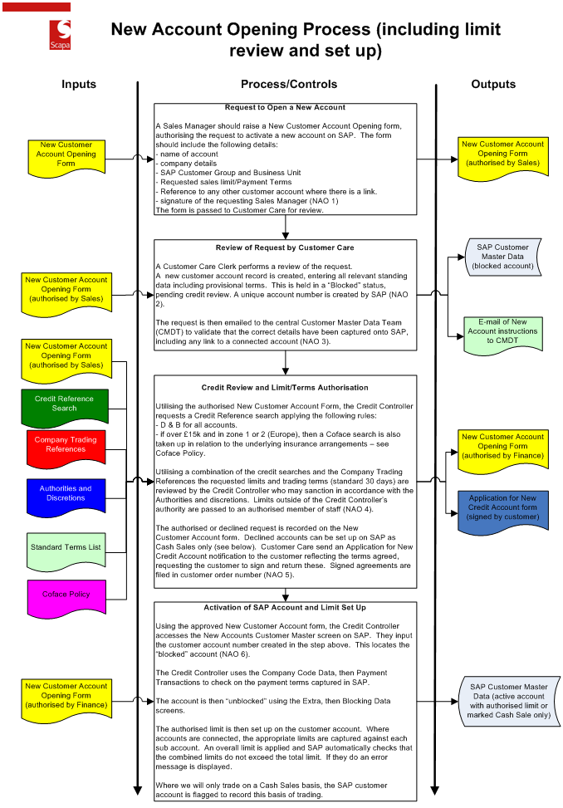

b. Orders on Hold or Stopped
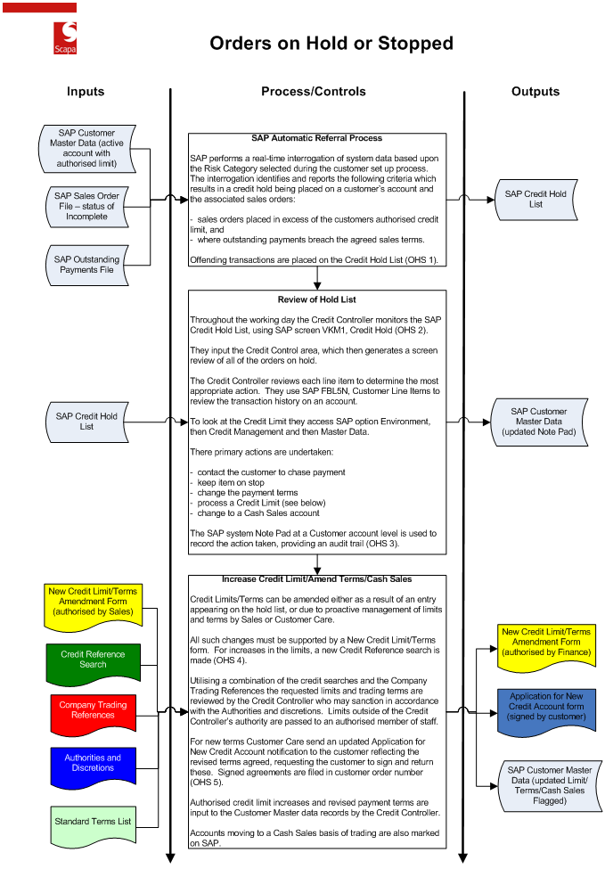

c. Proactive Collections
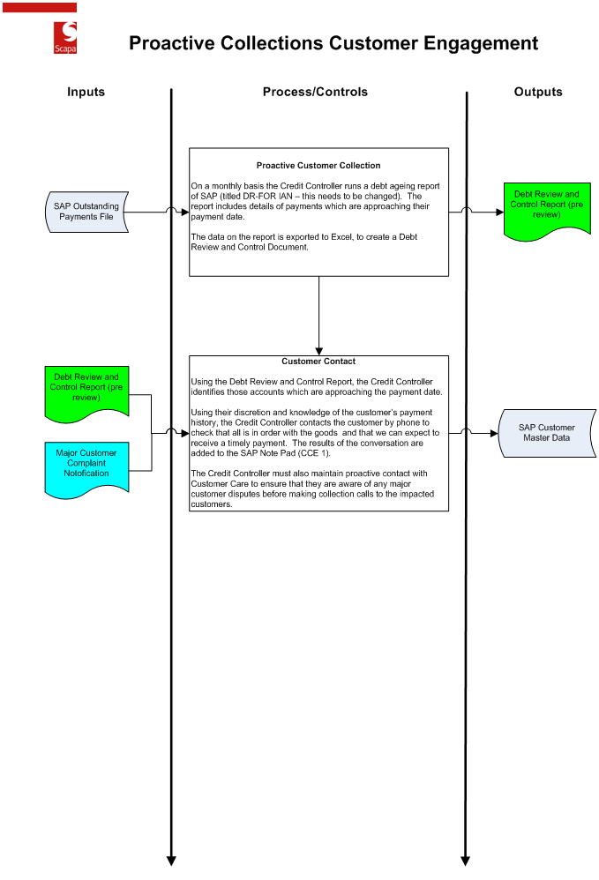

d. Processing Insurer Limit Changes
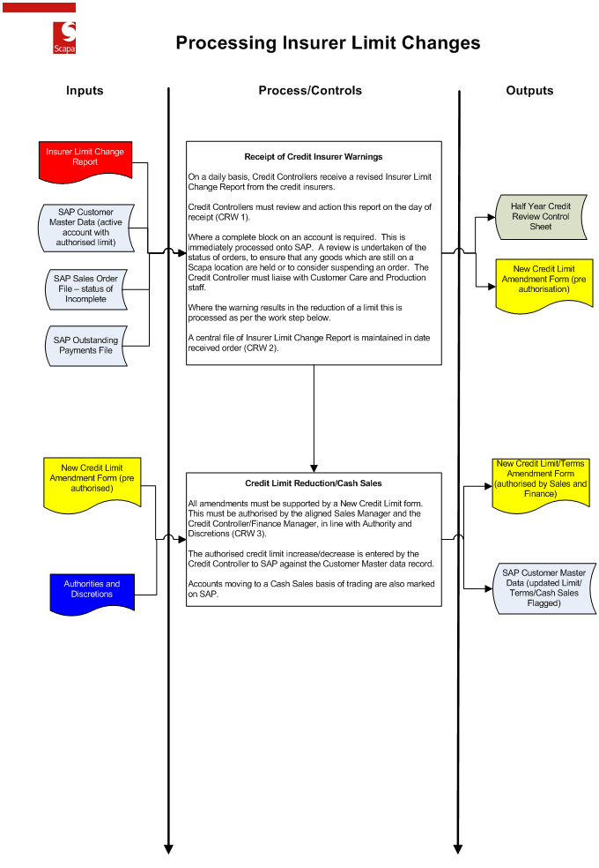

e. Debt Review and Escalation Process
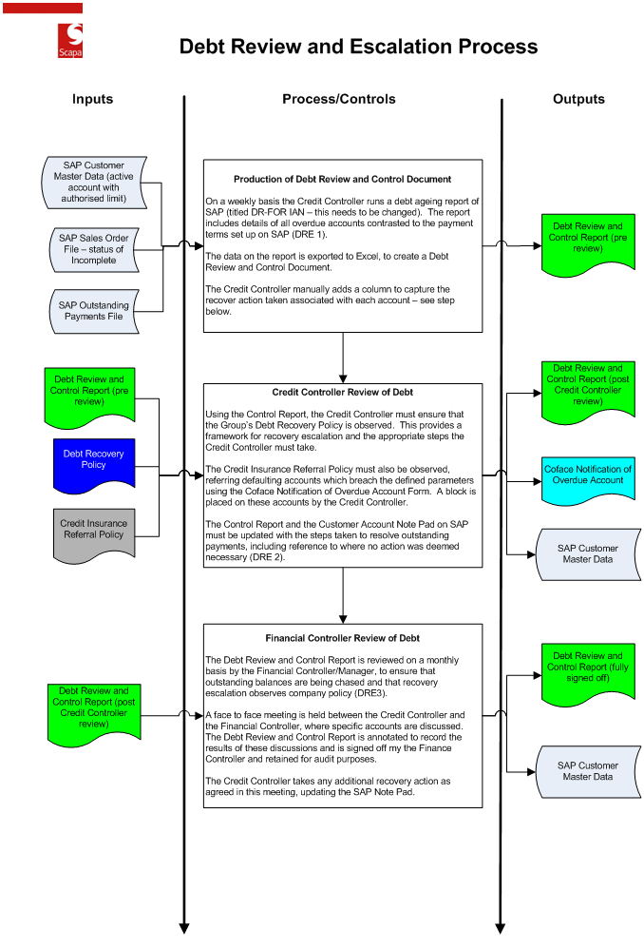

f. Debt Write Off
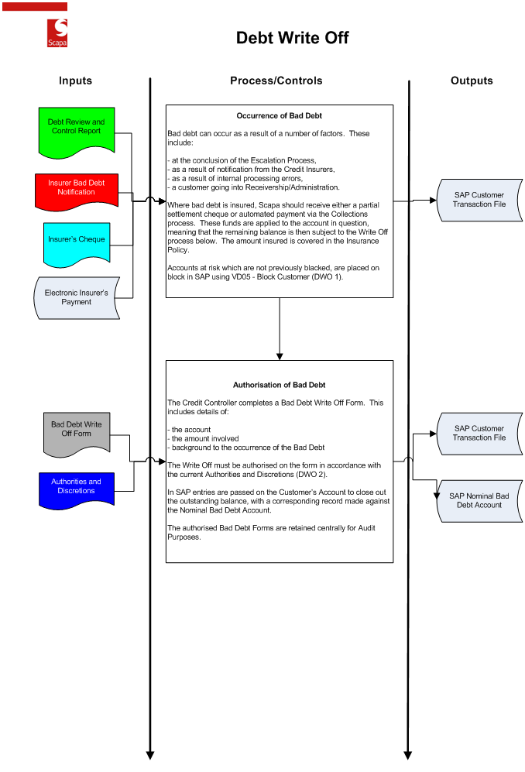

g. Statement Despatch
